Supermarket products from around the world
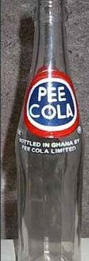
Well, it's still got to taste better thanMothers.
Just go 50/50 with Jim Beam no one will be the wiser !!!!!!!
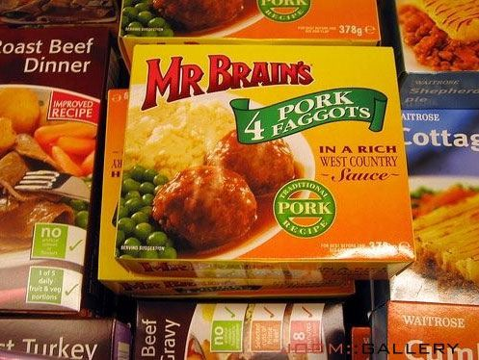
Okay?Must be Good!! ?

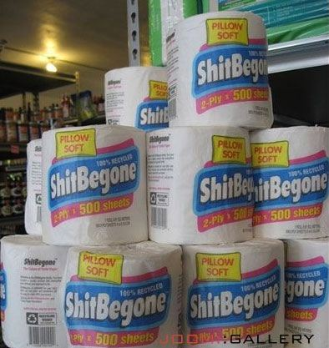
Be gone, I say!.
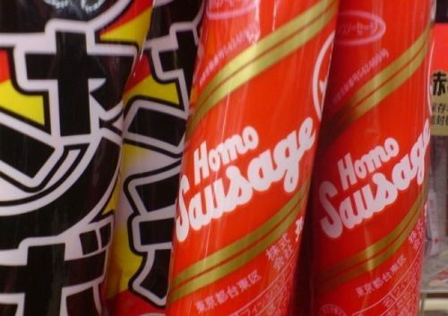
Not to be confused with Hetero sausage.
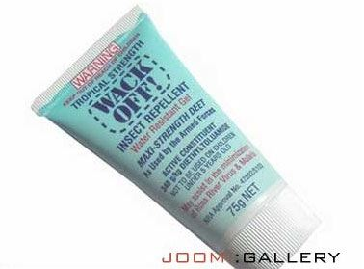
Insect repellent? Are you sure thats what its for?
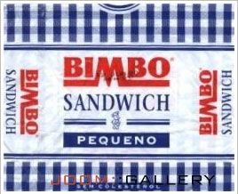
For Paris Hilton?

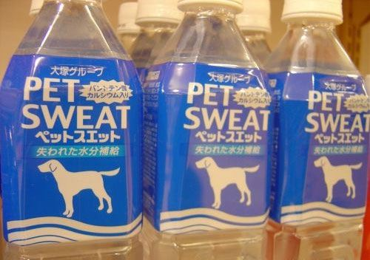
Soooo refreshing!
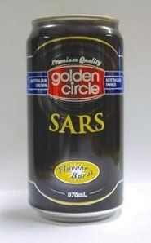
So thats where SARS came from! Thanks a lot Golden Circle jerks!
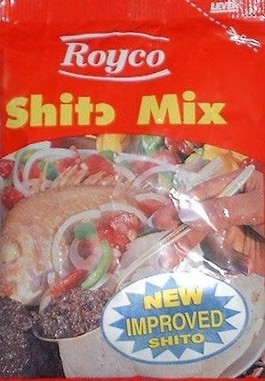
Only one thing better than regular Shito new, improved Shito.

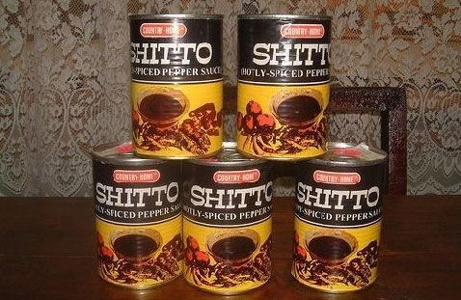
Spicy Hot Shit-o!
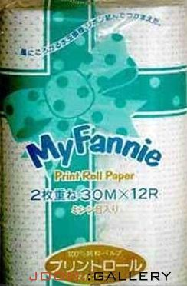

Hope thats not the the scent!!!!
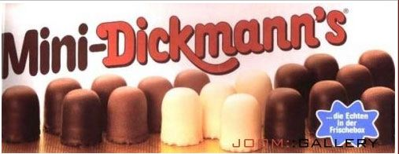

What are you looking at me for ?


Mines Happy anyway!
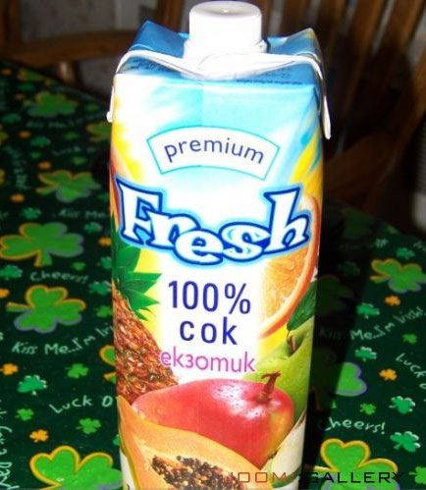
So much better than old, stale cok!
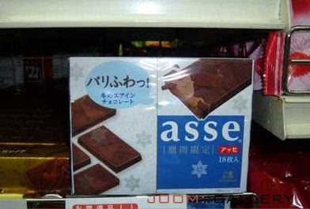
Well of course, Asse just had to be chocolate.
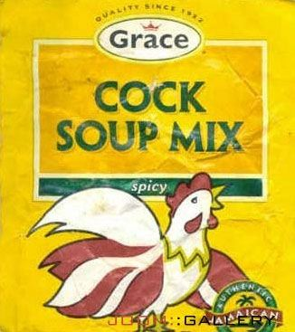
I really shouldnt find this funny...
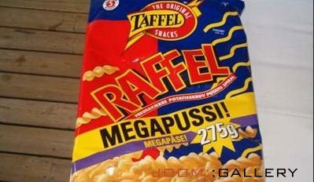
Wow!MEGA!! PUSSI !!!!

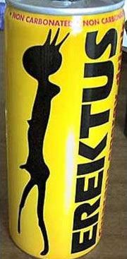
Hard to refuse!
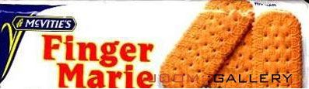
I hope Marie knows about this.
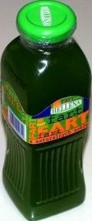
And they said it couldnt be bottled.
Colour is a worry though!

